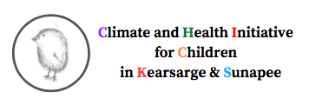

Adventures in Climate and Health
End of Semester Survey!

- Would you recommend Adventures in Climate & Health to your friends?

- What were your three favorite activities?

- Have you talked about Adventures in Climate and Health with your friends or family?

- How many of the activities have you tried at home?

- What, if anything, are you doing differently because of the activities?

- Would you like to do more Adventures in Climate & Health activities with the college students?

